# 实验四 **NoSQL和关系数据库的操作比较**

|  |  |  |  |  |
| --- | --- | --- | --- | --- |
| **地 点：** | B10楼 | 303房； | **实验台号：** |  |
| **实验日期与时间：** | 2023/4/6 | | **评 分：** |  |
| **预习检查纪录：** |  | | **实验教师：** | 焦青松 |

1. **实验目的**

**（1）.理解4种数据库(MySQL,HBase,Redis,MongoDB)的概念和不同点。**

**(2).熟练使用4种数据库操作常用的Shell命令**

**(3).熟悉4种数据库操作常用的Java API。**

1. **实验平台**

(1).操作系统:Linux

(2).Hadoop版本:3.3.5

(3).Hbase版本：3.0.0

(4).JDK版本:19.3.0

(5).Java IDE:eclipse

(6).Redis版本:6.0.0

(7)MySQL版本:8.0

(8).MongoDB版本:6.0.5

1. **实验步骤（包括实验结果/截图）**

**Redis的安装**

**先下载.tar.gz。之后使用make命令进行编译。**

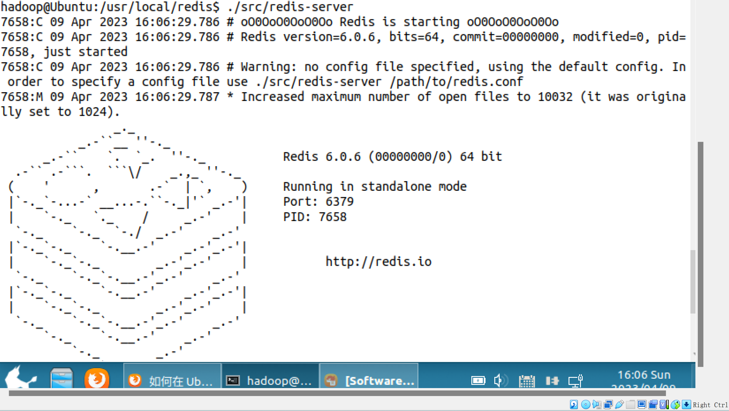

**Redis安装成功。**

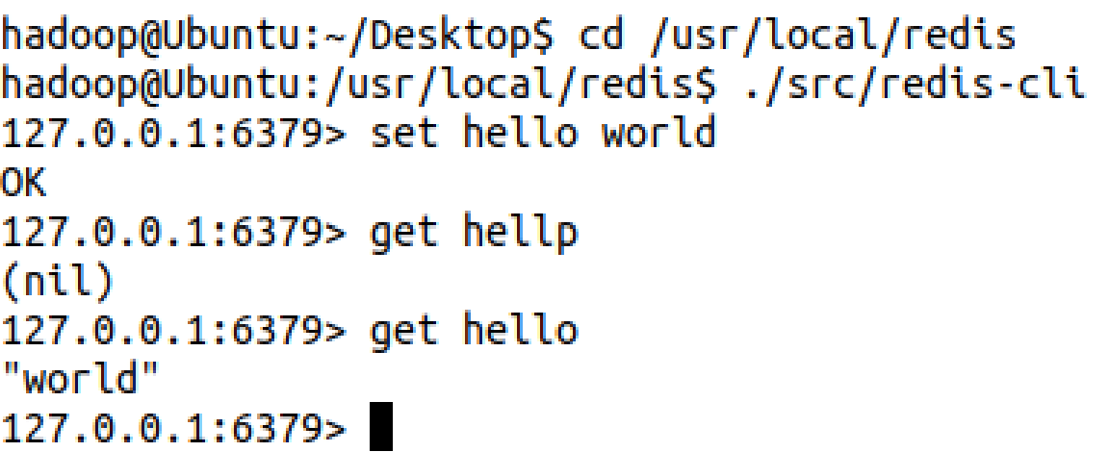

**客户端连上服务器。**

**MySQL的安装 这里直接使用了apt-get的方法的进行安装，很方便。**

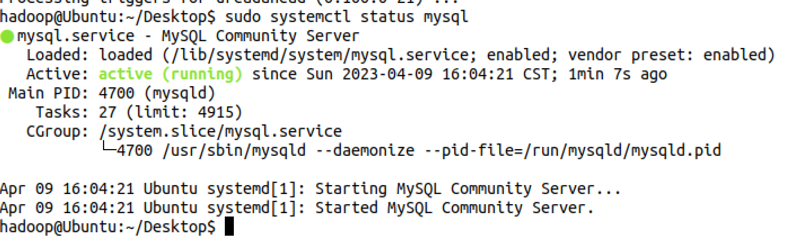

**Mysql安装成功。**

**MongoDB的安装**

**从他们官网上找方法安装。**

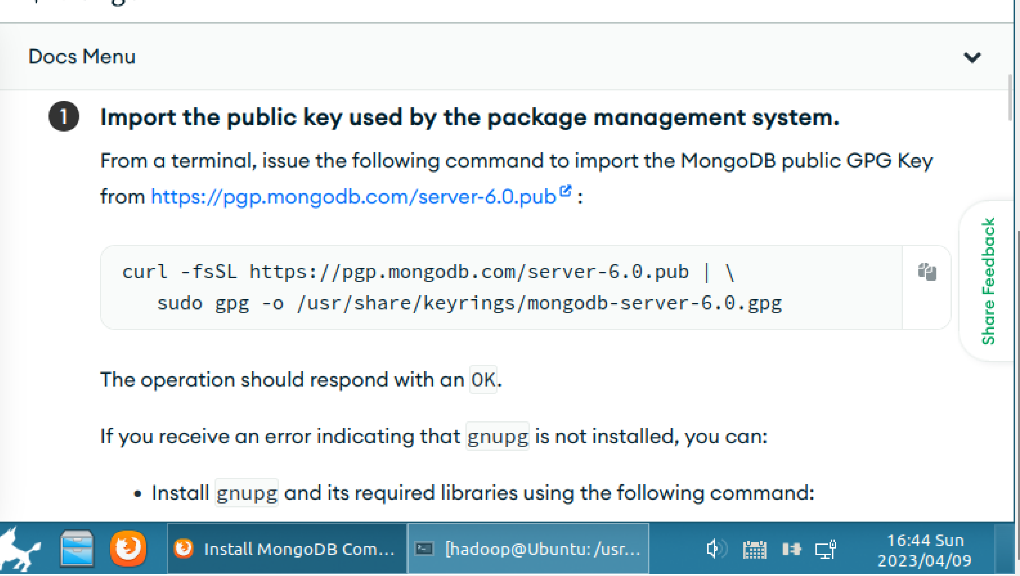

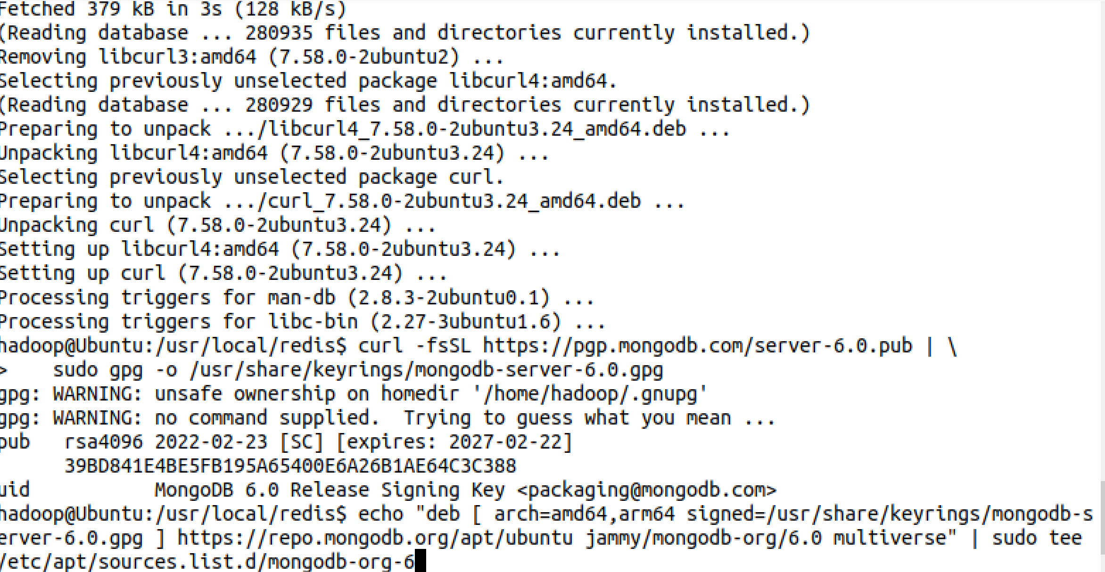

**更新源**

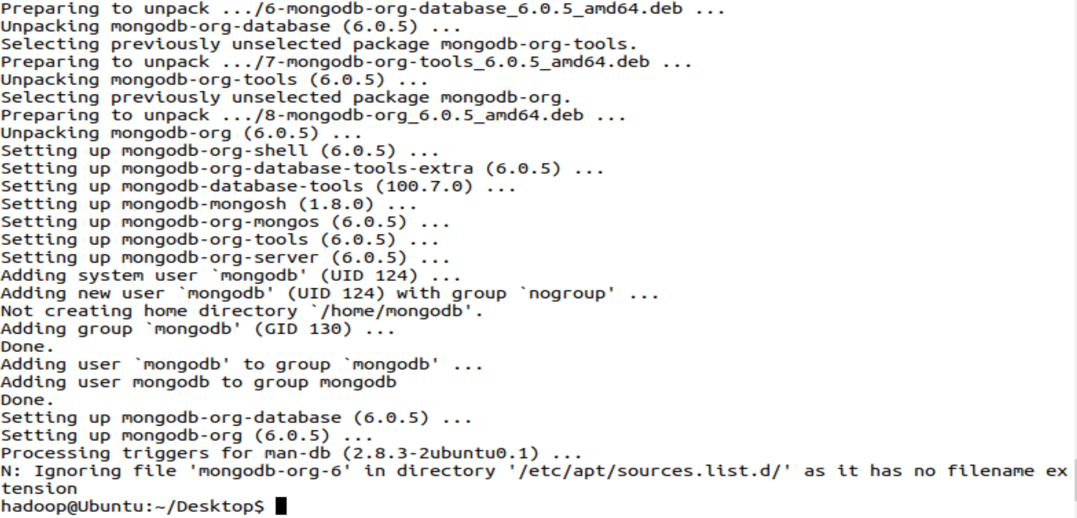

**在6.0版本mongoDB以后，需要安装mongodb-clients才能进行。**

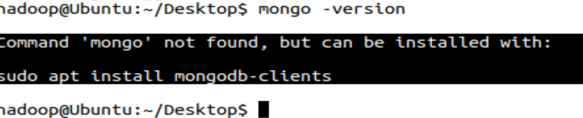

**启动成功**

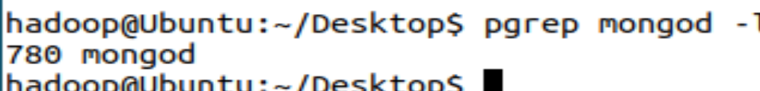

**Java API编程实例**

**先下载jar包，之后新建项目。**

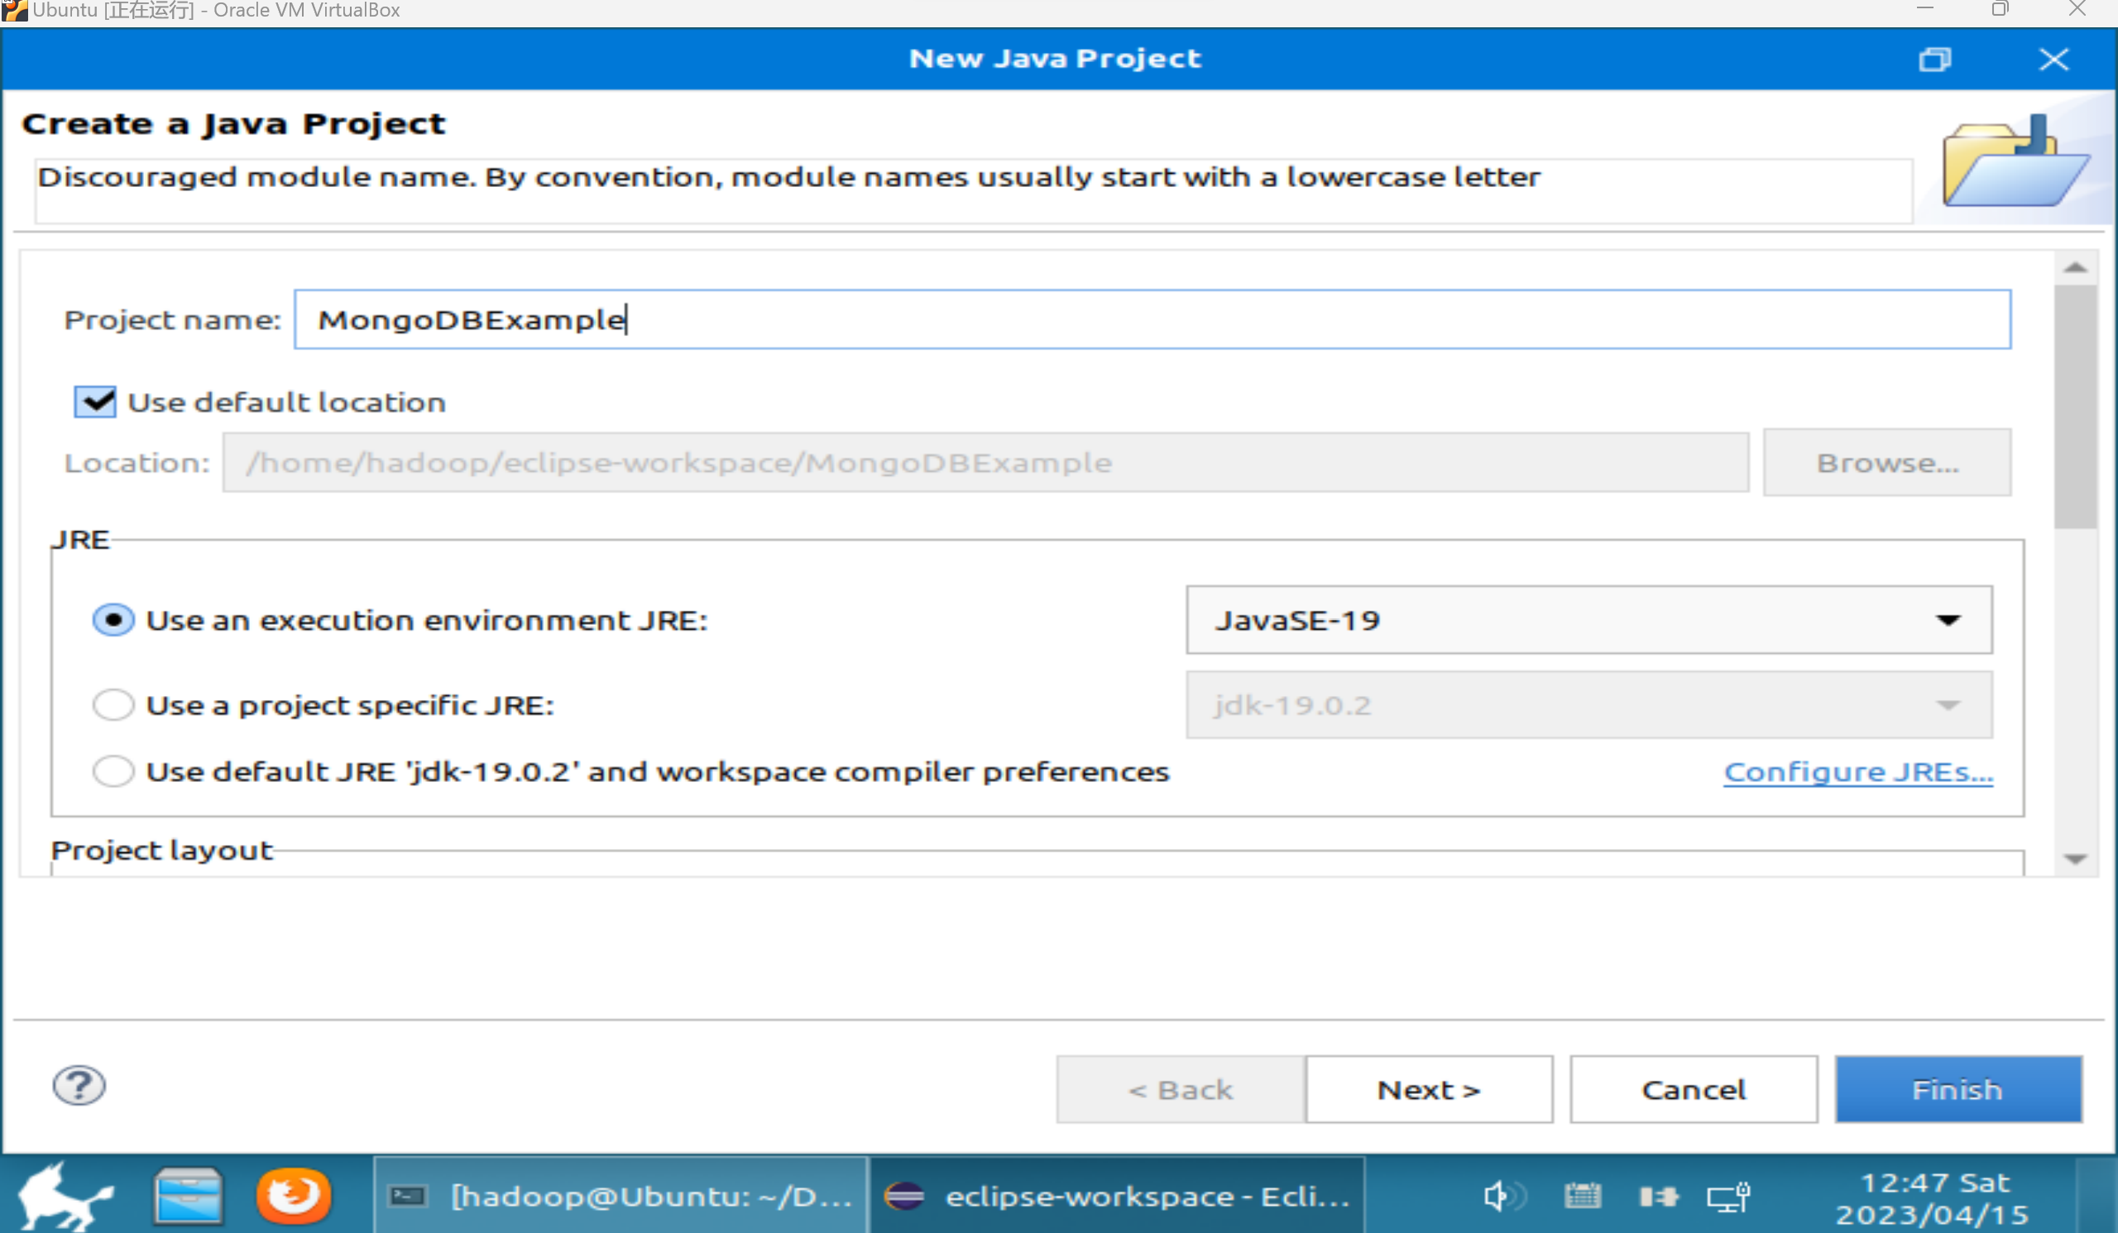

**添加jar包**

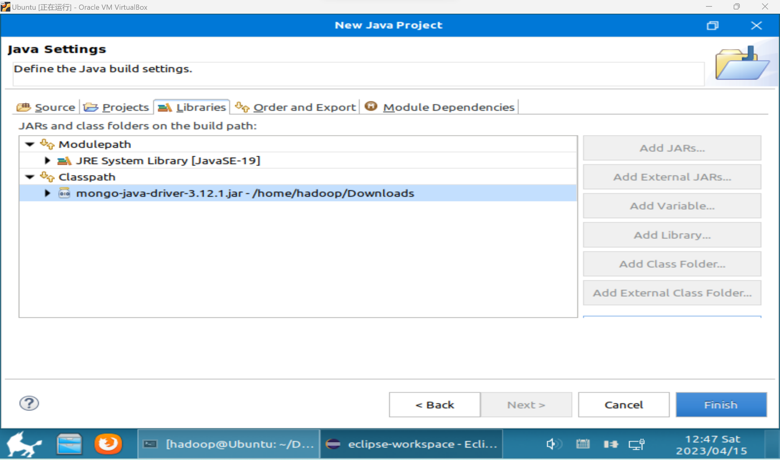

**Mysql数据库操作**

**登陆mysql**

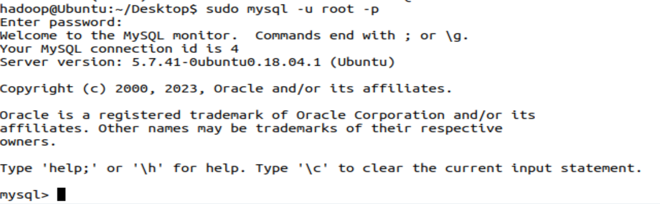

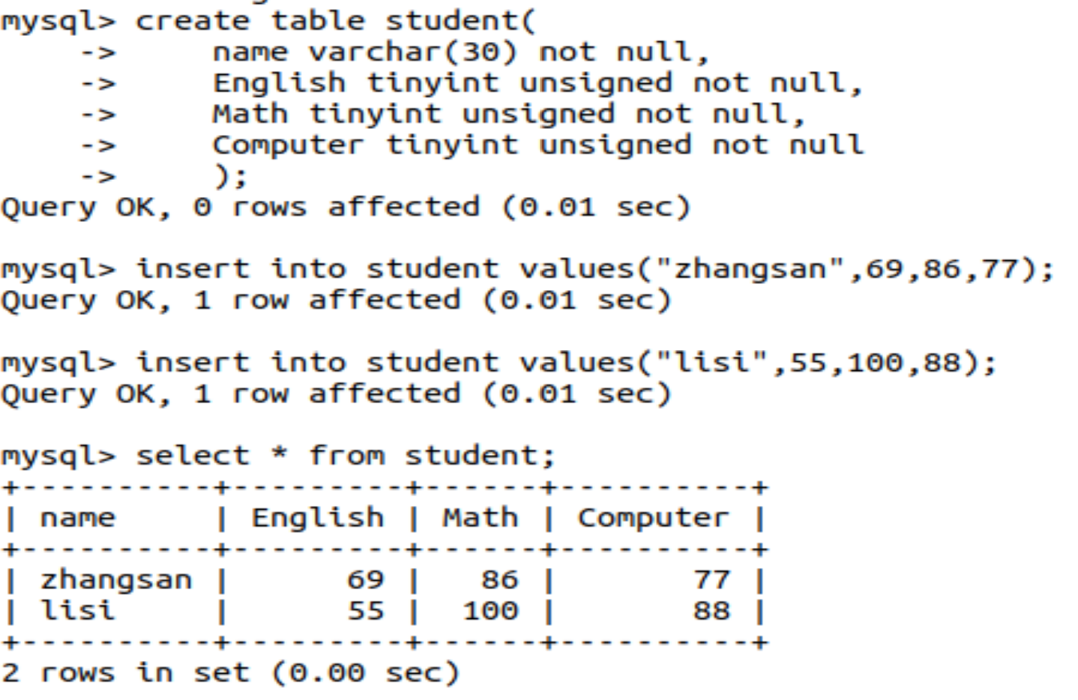

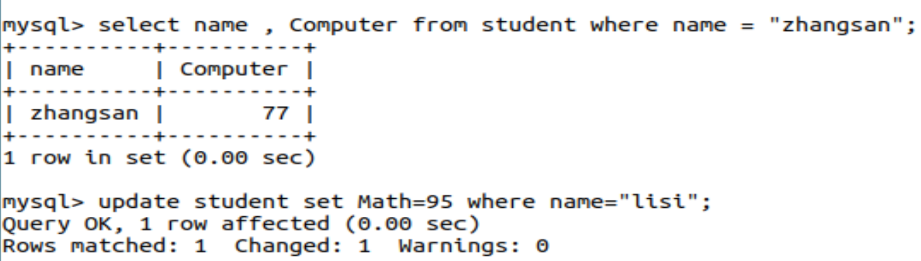

**使用java编程。**

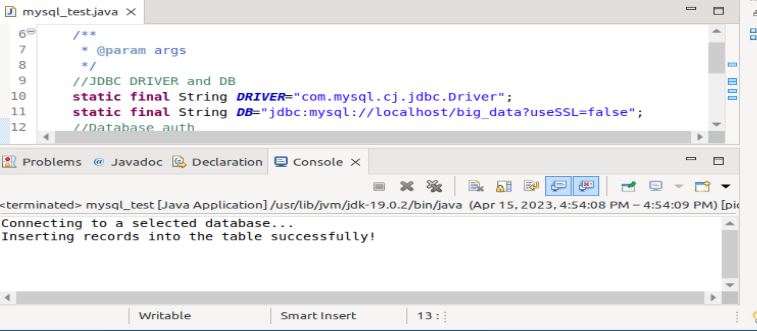

**Hbase操作**

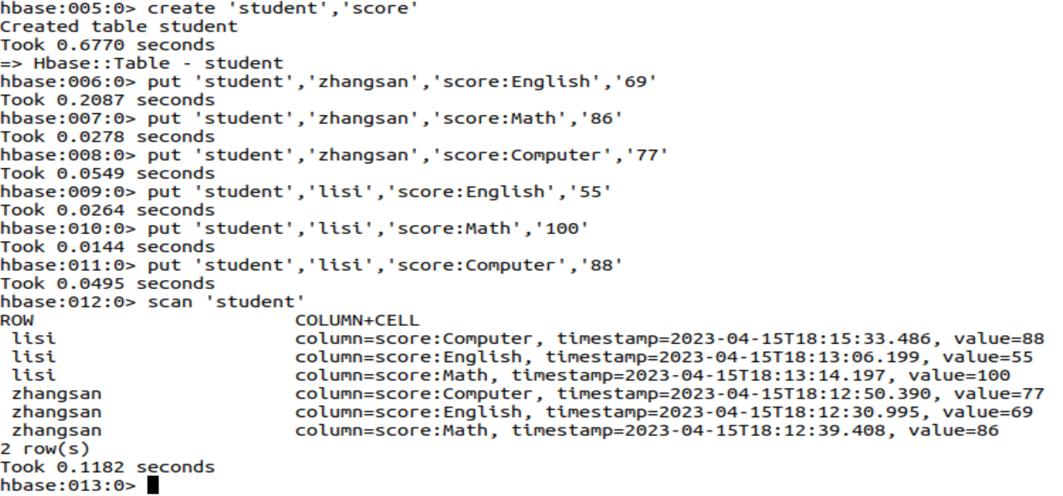

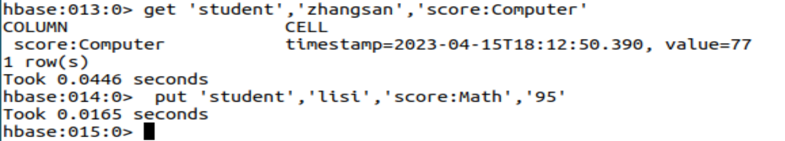

**添加数据**

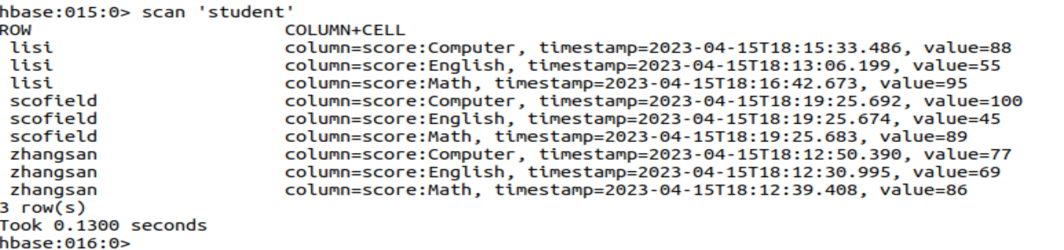

**使用java获取数据**

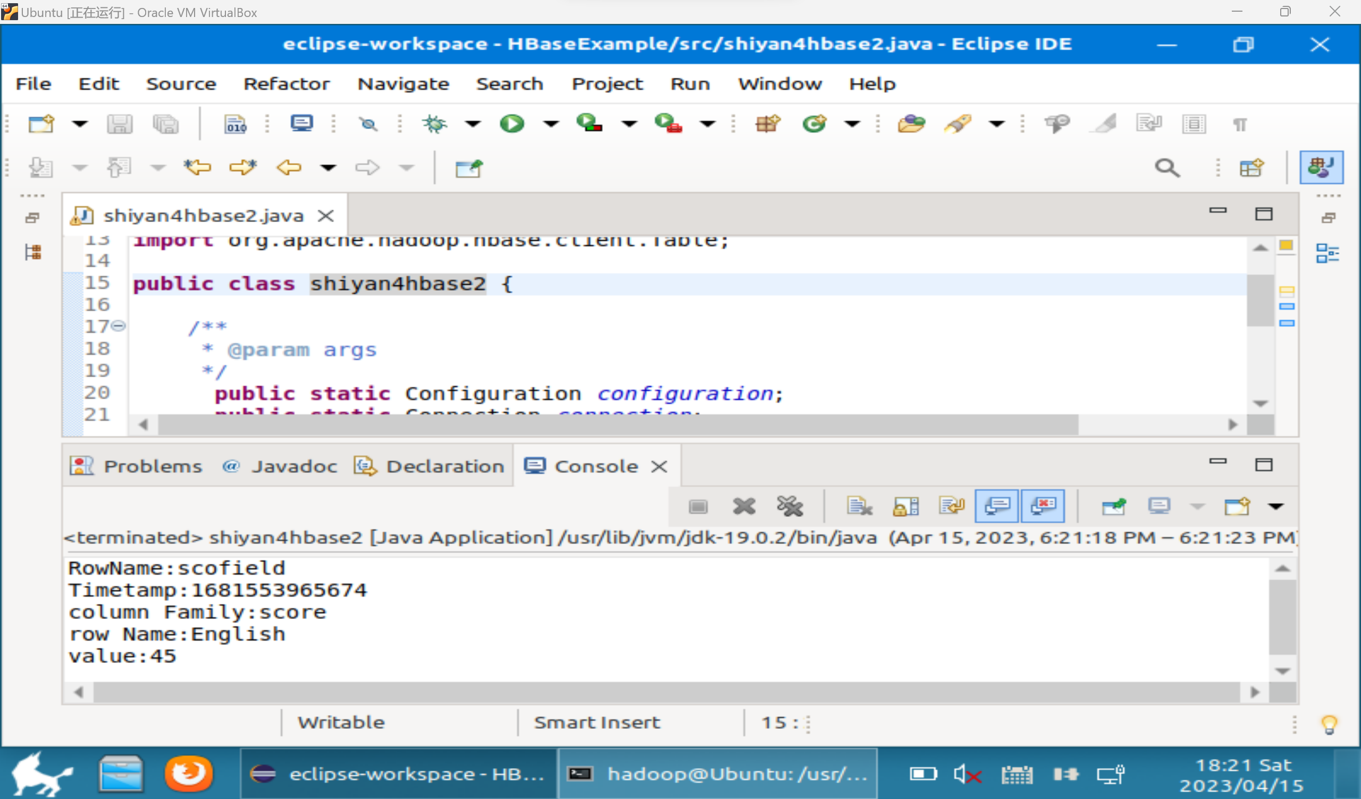

**Redis操作**

**使用shell操作**

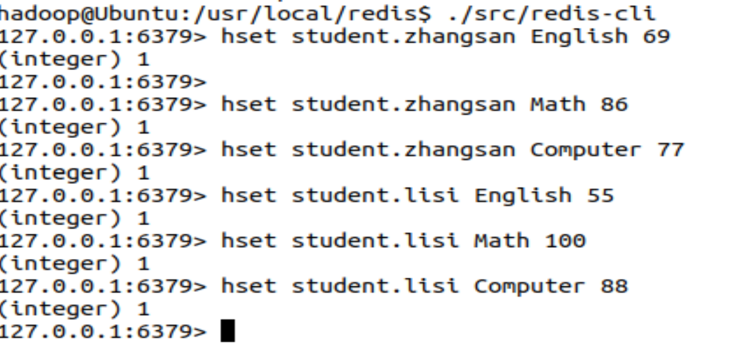

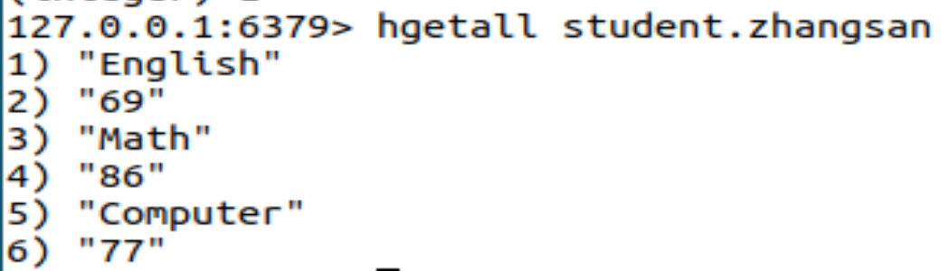

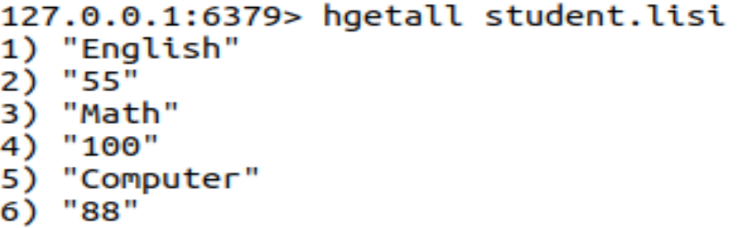





1. **思考讨论题或体会或对改进实验的建议**

**4种数据库的使用方法需要熟练掌握，nosql数据库和关系型数据库之间的区别与联系也值得探讨。**

1. **实验源代码**

**cd ~**

**sudo tar -zxvf ./下载/redis-5.0.5.tar.gz -C /usr/local**

**cd /usr/local**

**sudo mv ./redis-5.0.5 ./redis**

sudo apt install mysql-server

sudo apt update

sudo systemctl status mysql

curl -fsSL https://pgp.mongodb.com/server-6.0.pub | \

sudo gpg -o /usr/share/keyrings/mongodb-server-6.0.gpg

import java.util.ArrayList;

import java.util.List;

import org.bson.Document;

import com.mongodb.MongoClient;

import com.mongodb.client.MongoCollection;

import com.mongodb.client.MongoCursor;

import com.mongodb.client.MongoDatabase;

import com.mongodb.client.model.Filters;

public class TestMongoDB {

/**

* @param args

*/

public static void main(String[] args) {

// insert();//插入数据。执行插入时，可将其他三句函数调用语句注释，下同

find(); //查找数据

// update();//更新数据

// delete();//删除数据

}

/**

* 返回指定数据库中的指定集合

* @param dbname 数据库名

* @param collectionname 集合名

* @return

*/

//MongoDB无需预定义数据库和集合,在使用的时候会自动创建

public static MongoCollection<Document> getCollection(String dbname,String collectionname){

//实例化一个mongo客户端,服务器地址：localhost(本地)，端口号：27017

MongoClient mongoClient=new MongoClient("localhost",27017);

//实例化一个mongo数据库

MongoDatabase mongoDatabase = mongoClient.getDatabase(dbname);

//获取数据库中某个集合

MongoCollection<Document> collection = mongoDatabase.getCollection(collectionname);

return collection;

}

/**

* 插入数据

*/

public static void insert(){

try{

//连接MongoDB，指定连接数据库名，指定连接表名。

MongoCollection<Document> collection= getCollection("School","student"); //数据库名:School 集合名:student

//实例化一个文档,文档内容为{sname:'Mary',sage:25}，如果还有其他字段，可以继续追加append

Document doc1=new Document("sname","Mary").append("sage", 25);

//实例化一个文档,文档内容为{sname:'Bob',sage:20}

Document doc2=new Document("sname","Bob").append("sage", 20);

List<Document> documents = new ArrayList<Document>();

//将doc1、doc2加入到documents列表中

documents.add(doc1);

documents.add(doc2);

//将documents插入集合

collection.insertMany(documents);

System.out.println("插入成功");

}catch(Exception e){

System.err.println( e.getClass().getName() + ": " + e.getMessage() );

}

}

/**

* 查询数据

*/

public static void find(){

try{

MongoCollection<Document> collection = getCollection("School","student"); //数据库名:School 集合名:student

//通过游标遍历检索出的文档集合

// MongoCursor<Document> cursor= collection.find(new Document("sname","Mary")). projection(new Document("sname",1).append("sage",1).append("_id", 0)).iterator(); //find查询条件：sname='Mary'。projection筛选：显示sname和sage,不显示_id(_id默认会显示)

//查询所有数据

MongoCursor<Document> cursor= collection.find().iterator();

while(cursor.hasNext()){

System.out.println(cursor.next().toJson());

}

}catch(Exception e){

System.err.println( e.getClass().getName() + ": " + e.getMessage() );

}

}

/**

* 更新数据

*/

public static void update(){

try{

MongoCollection<Document> collection = getCollection("School","student"); //数据库名:School 集合名:student

//更新文档，将文档中sname='Mary'的文档修改为sage=22

collection.updateMany(Filters.eq("sname", "Mary"), new Document("$set",new Document("sage",22)));

System.out.println("更新成功！");

}catch(Exception e){

System.err.println( e.getClass().getName() + ": " + e.getMessage() );

}

}

/**

* 删除数据

*/

public static void delete(){

try{

MongoCollection<Document> collection = getCollection("School","student"); //数据库名:School 集合名:student

//删除符合条件的第一个文档

collection.deleteOne(Filters.eq("sname", "Bob"));

//删除所有符合条件的文档

//collection.deleteMany (Filters.eq("sname", "Bob"));

System.out.println("删除成功！");

}catch(Exception e){

System.err.println( e.getClass().getName() + ": " + e.getMessage() );

}

}

}

import java.io.IOException;

import org.apache.hadoop.conf.Configuration;

import org.apache.hadoop.hbase.HBaseConfiguration;

import org.apache.hadoop.hbase.TableName;

import org.apache.hadoop.hbase.client.Admin;

import org.apache.hadoop.hbase.client.Connection;

import org.apache.hadoop.hbase.client.ConnectionFactory;

import org.apache.hadoop.hbase.client.Put;

import org.apache.hadoop.hbase.client.Table;

public class hbase_insert {

/**

* @param args

*/

public static Configuration configuration;

public static Connection connection;

public static Admin admin;

public static void main(String[] args) {

// TODO Auto-generated method stub

configuration = HBaseConfiguration.create();

configuration.set("hbase.rootdir","hdfs://localhost:9000/hbase");

try{

connection = ConnectionFactory.createConnection(configuration);

admin = connection.getAdmin();

}catch (IOException e){

e.printStackTrace();

}

try {

insertRow("student","scofield","score","English","45");

insertRow("student","scofield","score","Math","89");

insertRow("student","scofield","score","Computer","100");

} catch (IOException e) {

// TODO Auto-generated catch block

e.printStackTrace();

}

close();

}

public static void insertRow(String tableName,String rowKey,String colFamily,

String col,String val) throws IOException {

Table table = connection.getTable(TableName.valueOf(tableName));

Put put = new Put(rowKey.getBytes());

put.addColumn(colFamily.getBytes(), col.getBytes(), val.getBytes());

table.put(put);

table.close();

}

public static void close(){

try{

if(admin != null){

admin.close();

}

if(null != connection){

connection.close();

}

}catch (IOException e){

e.printStackTrace();

}

}

}

**import java.io.IOException;**

**import org.apache.hadoop.conf.Configuration;**

**import org.apache.hadoop.hbase.Cell;**

**import org.apache.hadoop.hbase.CellUtil;**

**import org.apache.hadoop.hbase.HBaseConfiguration;**

**import org.apache.hadoop.hbase.TableName;**

**import org.apache.hadoop.hbase.client.Admin;**

**import org.apache.hadoop.hbase.client.Connection;**

**import org.apache.hadoop.hbase.client.ConnectionFactory;**

**import org.apache.hadoop.hbase.client.Get;**

**import org.apache.hadoop.hbase.client.Put;**

**import org.apache.hadoop.hbase.client.Result;**

**import org.apache.hadoop.hbase.client.Table;**

**public class hbase_query {**

**/\*\***

**\* @param args**

**\*/**

**public static Configuration configuration;**

**public static Connection connection;**

**public static Admin admin;**

**public static void main(String[] args) {**

**// TODO Auto-generated method stub**

**configuration = HBaseConfiguration.create();**

**configuration.set("hbase.rootdir","hdfs://localhost:9000/hbase");**

**try{**

**connection = ConnectionFactory.createConnection(configuration);**

**admin = connection.getAdmin();**

**}catch (IOException e){**

**e.printStackTrace();**

**}**

**try {**

**getData("student","scofield","score","English");**

**} catch (IOException e) {**

**// TODO Auto-generated catch block**

**e.printStackTrace();**

**}**

**close();**

**}**

**public static void getData(String tableName,String rowKey,String colFamily,**

**String col)throws IOException{**

**Table table = connection.getTable(TableName.valueOf(tableName));**

**Get get = new Get(rowKey.getBytes());**

**get.addColumn(colFamily.getBytes(),col.getBytes());**

**Result result = table.get(get);**

**showCell(result);**

**table.close();**

**}**

**public static void showCell(Result result){**

**Cell[] cells = result.rawCells();**

**for(Cell cell:cells){**

**System.out.println("RowName:"+new String(CellUtil.cloneRow(cell))+" ");**

**System.out.println("Timetamp:"+cell.getTimestamp()+" ");**

**System.out.println("column Family:"+new String(CellUtil.cloneFamily(cell))+" ");**

**System.out.println("row Name:"+new String(CellUtil.cloneQualifier(cell))+" ");**

**System.out.println("value:"+new String(CellUtil.cloneValue(cell))+" ");**

**}**

**}**

**public static void close(){**

**try{**

**if(admin != null){**

**admin.close();**

**}**

**if(null != connection){**

**connection.close();**

**}**

**}catch (IOException e){**

**e.printStackTrace();**

**}**

**}**

**}**

hset student.zhangsan English 69

hset student.zhangsan Math 86

hset student.zhangsan Computer 77

hset student.lisi English 55

hset student.lisi Math 100

hset student.lisi Computer 88

**import java.util.Map;**

**import redis.clients.jedis.Jedis;**

**public class jedis_test {**

**/\*\***

**\* @param args**

**\*/**

**public static void main(String[] args) {**

**// TODO Auto-generated method stub**

**Jedis jedis = new Jedis("localhost");**

**jedis.hset("student.scofield", "English","45");**

**jedis.hset("student.scofield", "Math","89");**

**jedis.hset("student.scofield", "Computer","100");**

**Map<String,String> value = jedis.hgetAll("student.scofield");**

**for(Map.Entry<String, String> entry:value.entrySet())**

**{**

**System.out.println(entry.getKey()+":"+entry.getValue());**

**}**

**}**

**}**

**import java.util.Map;**

**import redis.clients.jedis.Jedis;**

**public class jedis_query {**

**/\*\***

**\* @param args**

**\*/**

**public static void main(String[] args) {**

**// TODO Auto-generated method stub**

**Jedis jedis = new Jedis("localhost");**

**String value=jedis.hget("student.scofield", "English");**

**System.out.println("scofield's English score is: "+value);**

**}**

**}**

**import java.util.ArrayList;**

**import java.util.List;**

**import org.bson.Document;**

**import com.mongodb.MongoClient;**

**import com.mongodb.client.MongoCollection;**

**import com.mongodb.client.MongoDatabase;**

**public class mongo_insert {**

**/\*\***

**\* @param args**

**\*/**

**public static void main(String[] args) {**

**// TODO Auto-generated method stub**

**//实例化一个mongo客户端**

**MongoClient mongoClient=new MongoClient("localhost",27017);**

**//实例化一个mongo数据库**

**MongoDatabase mongoDatabase = mongoClient.getDatabase("student");**

**//获取数据库中某个集合**

**MongoCollection<Document> collection = mongoDatabase.getCollection("student");**

**//实例化一个文档,内嵌一个子文档**

**Document document=new Document("name","scofield").**

**append("score", new Document("English",45).**

**append("Math", 89).**

**append("Computer", 100));**

**List<Document> documents = new ArrayList<Document>();**

**documents.add(document);**

**//将文档插入集合中**

**collection.insertMany(documents);**

**System.out.println("文档插入成功");**

**}**

**import java.util.ArrayList;**

**import java.util.List;**

**import org.bson.Document;**

**import com.mongodb.MongoClient;**

**import com.mongodb.client.MongoCollection;**

**import com.mongodb.client.MongoCursor;**

**import com.mongodb.client.MongoDatabase;**

**import com.mongodb.client.model.Filters;**

**import static com.mongodb.client.model.Filters.eq;**

**public class mongo_query {**

**/\*\***

**\* @param args**

**\*/**

**public static void main(String[] args) {**

**// TODO Auto-generated method stub**

**//实例化一个mongo客户端**

**MongoClient mongoClient=new MongoClient("localhost",27017);**

**//实例化一个mongo数据库**

**MongoDatabase mongoDatabase = mongoClient.getDatabase("student");**

**//获取数据库中某个集合**

**MongoCollection<Document> collection = mongoDatabase.getCollection("student");**

**//进行数据查找,查询条件为name=scofield, 对获取的结果集只显示score这个域**

**MongoCursor<Document> cursor=collection.find( new Document("name","scofield")).**

**projection(new Document("score",1).append("_id", 0)).iterator();**

**while(cursor.hasNext())**

**System.out.println(cursor.next().toJson());**

**}**

**}**